Pointers (Part 1 Basics)

LAB # 08



Spring 2022

CSE-102L COMPUTER PROGRAMMING LAB

Submitted by: MUHAMMAD SADEEQ

Registration No.: 21PWCSE2028

Section: C

"On my honor, as student of University of Engineering and Technology, I have neither given nor received unauthorized assistance on this academic work.'

Student Signature: _____________________

Submitted to:

Engr. Abdullah Hamid

(July 2022)

Department of Computer Systems Engineering University of Engineering and Technology, Peshawar

# Lab 8: Pointers (Part 1 Basics)

## Objectives:

To understand pointers and references.

Hint: You can also input values in pointers using cin>>*p;

## Tasks:

1. Write a C++ program where you take two values in two variables from user, add the values of the two variables and put it into a third variable using a pointer. you must you only one pointer.
2. Write a C++ program where you take two values from user in two variables, swaps the values of the variables using pointers.
3. Write a C++ program where you take a value in a variable from use increment that value by 5 using a pointer in a for loop and display its value using pointer.
4. Write a C++ program where you take your first name from user in a string variable, also in take your registration number from the user in another string variable. And then display both using a single pointer.
5. Display 1 to n numbers using pointer, user must enter the n.
6. Add even numbers from 1 to n using pointers user must enter n.

**COMPUTER PROGRAMMING LAB # 8**

**Answer #1**

**CODE:** 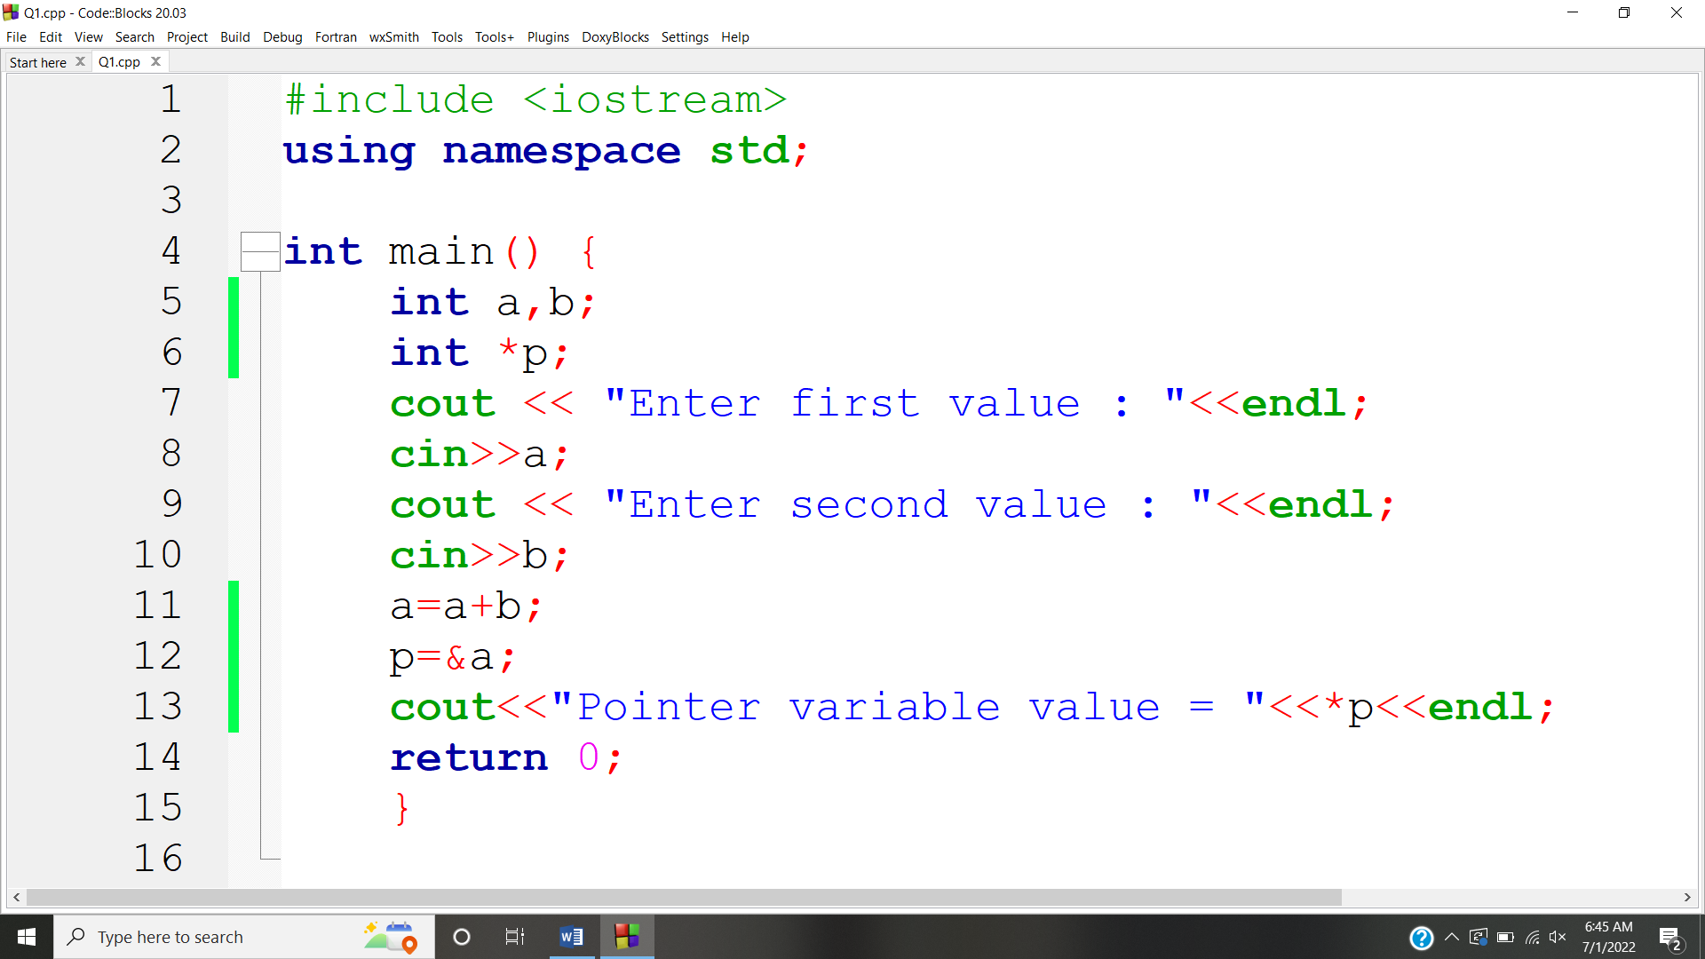

**OUTPUT:** 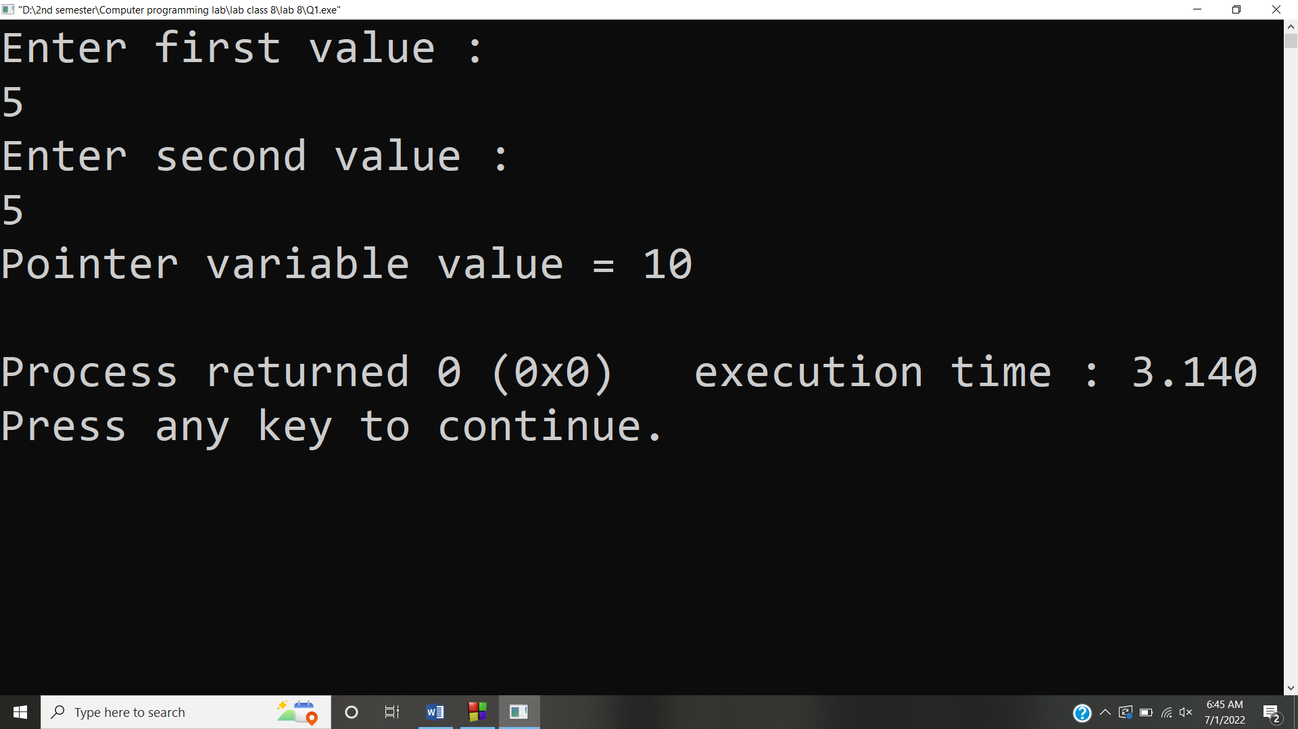

**Answer #2**

**CODE:** 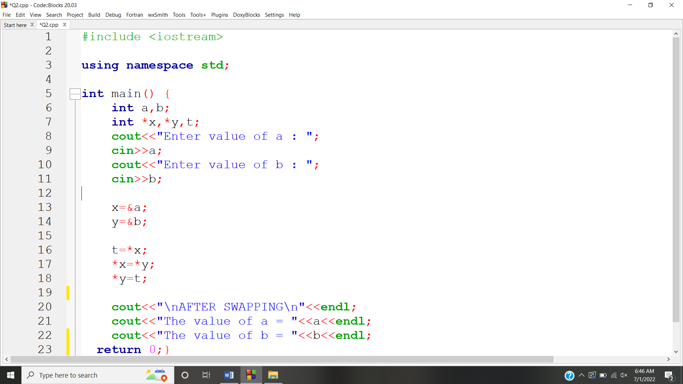

**OUTPUT:** 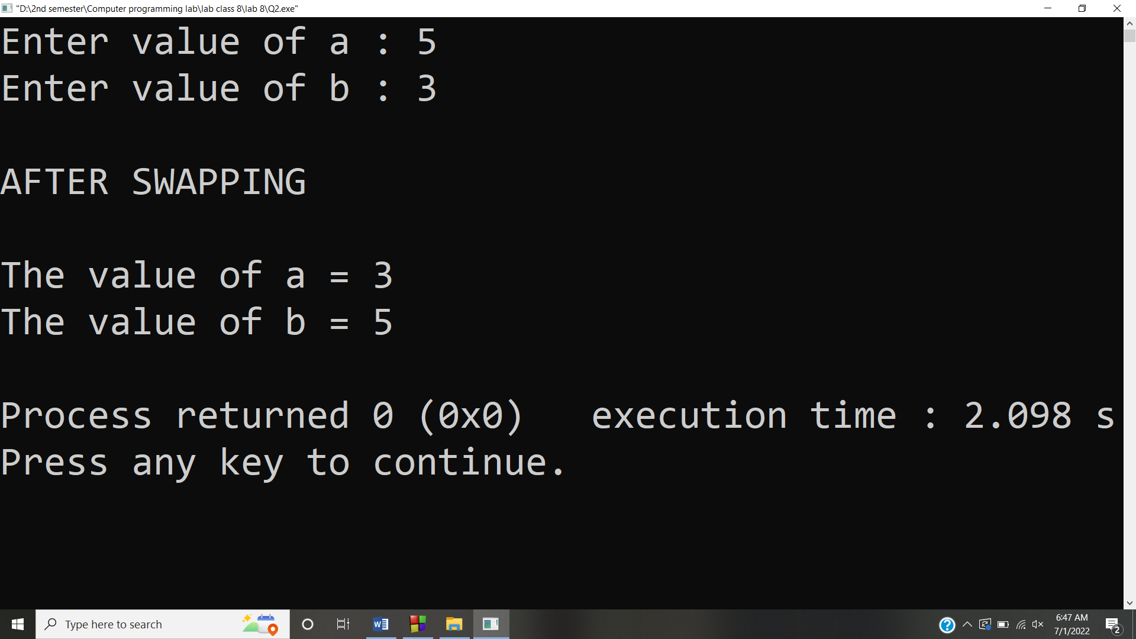

**Answer #3**

**CODE:** 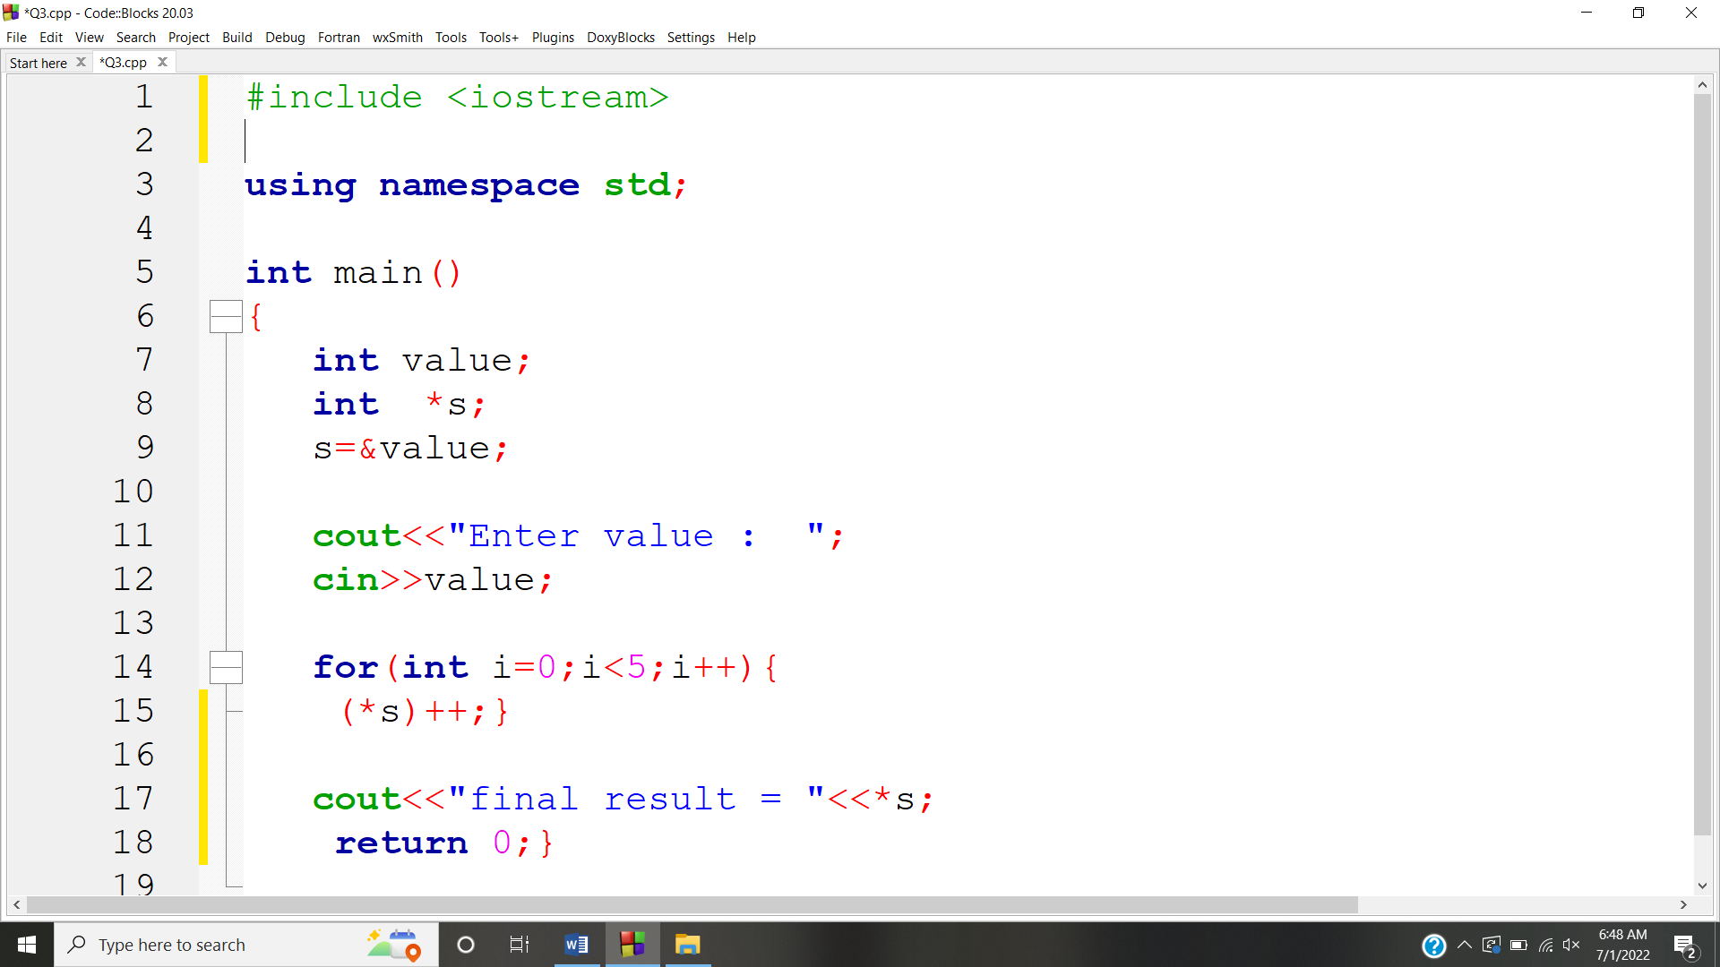

**OUTPUT:** 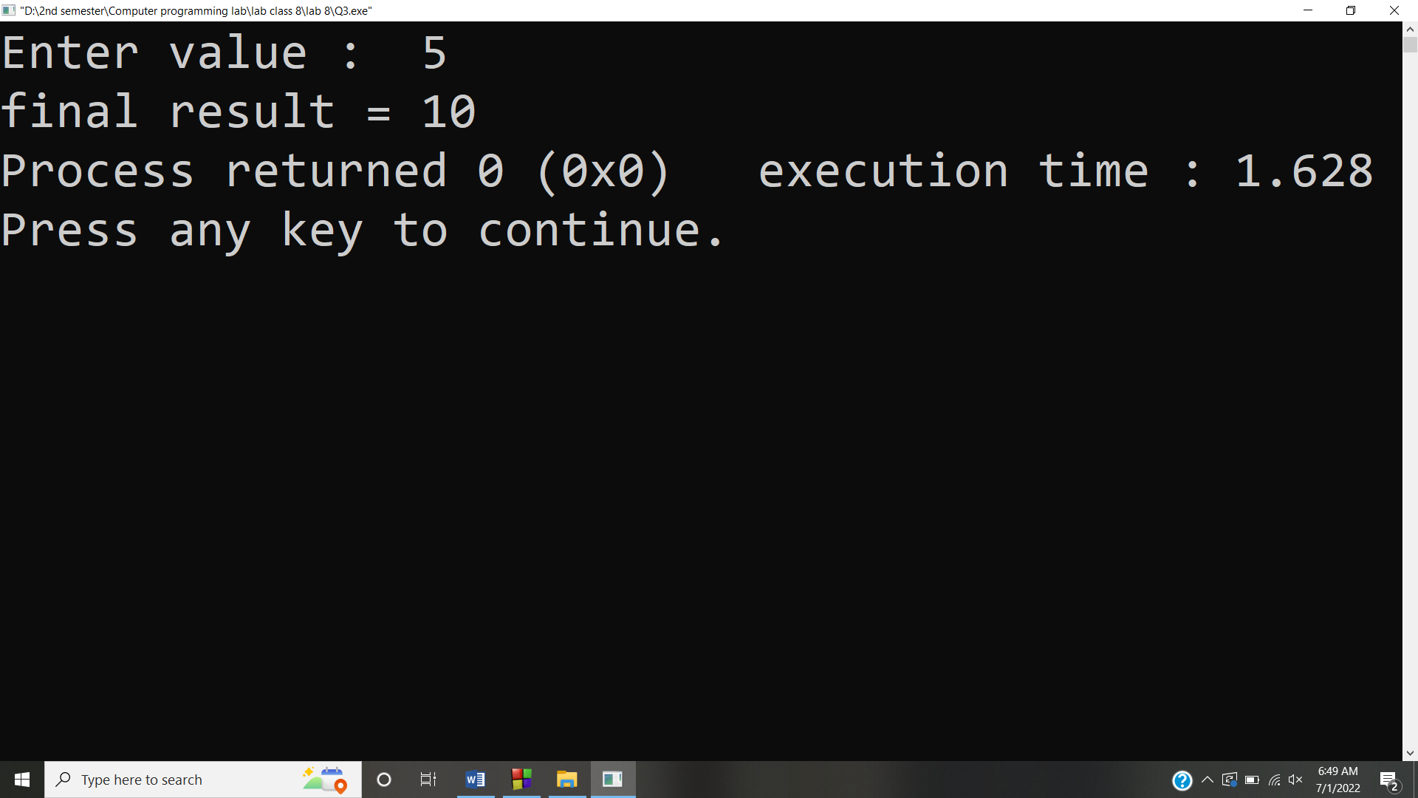

**Answer #4**

**CODE:** 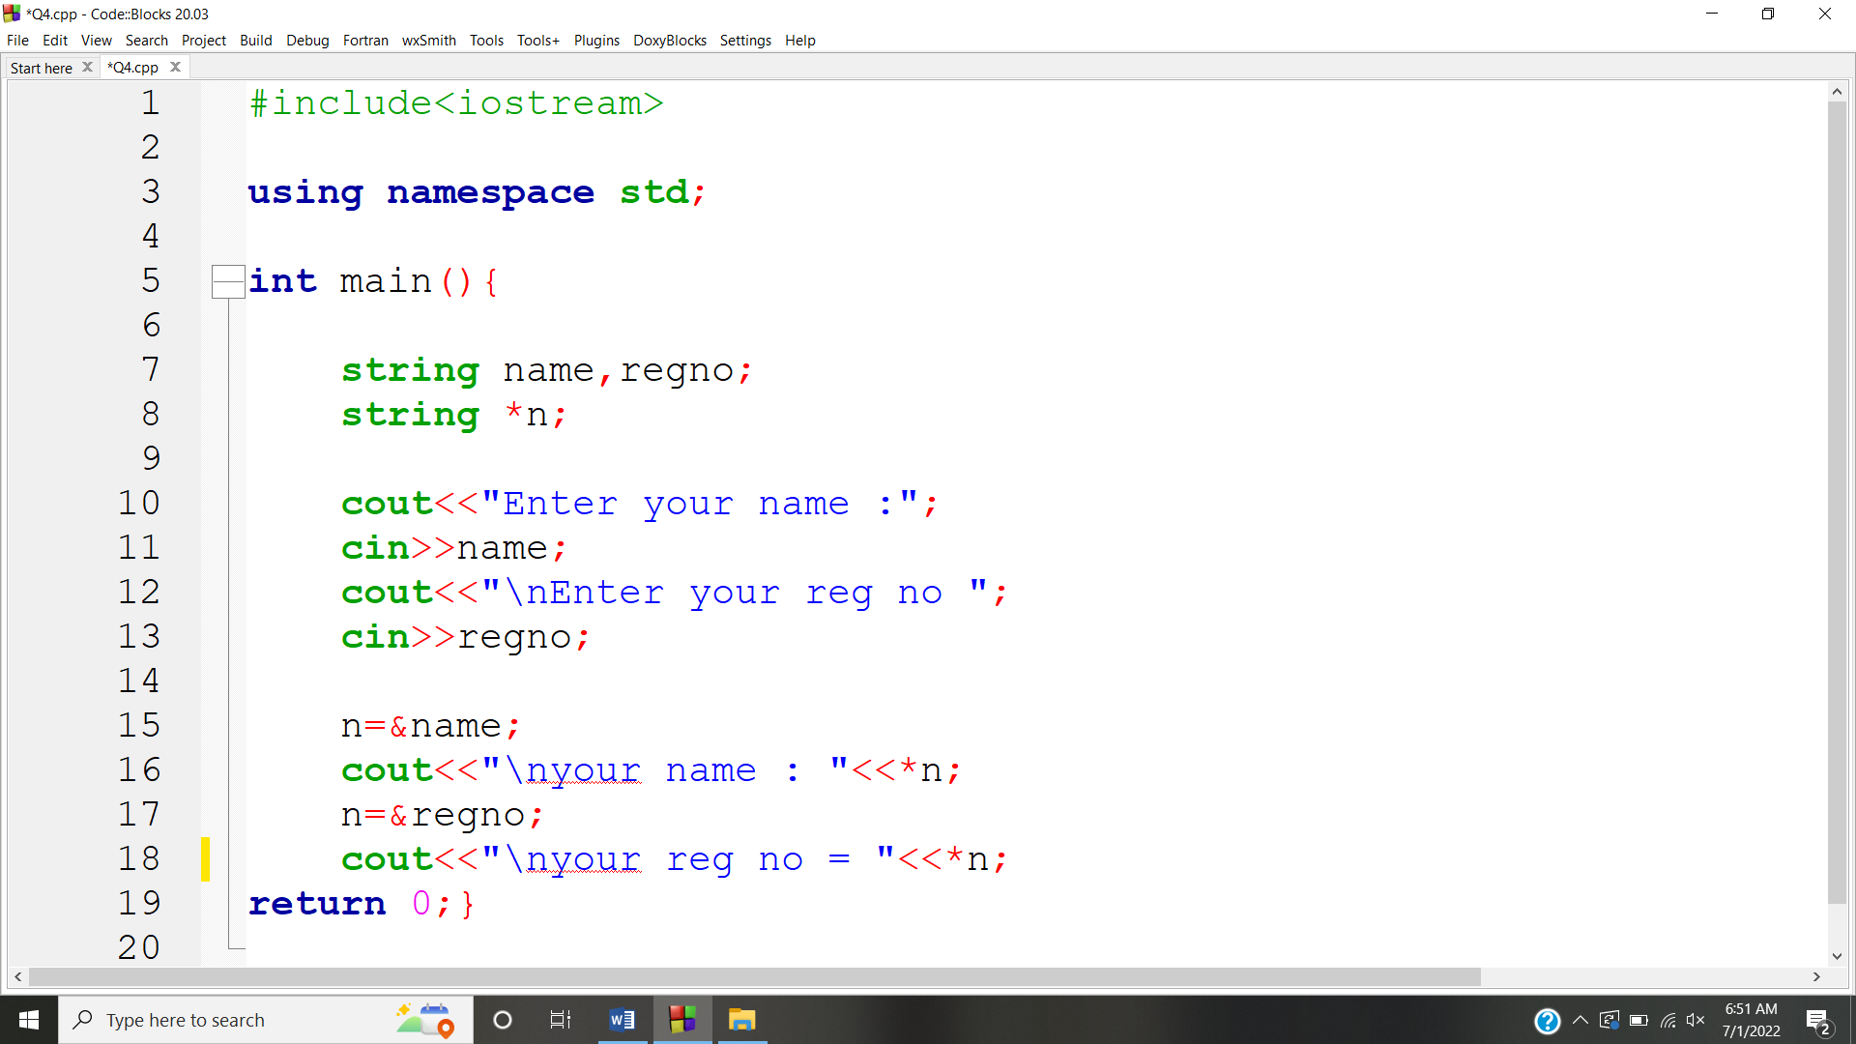

**OUTPUT:** 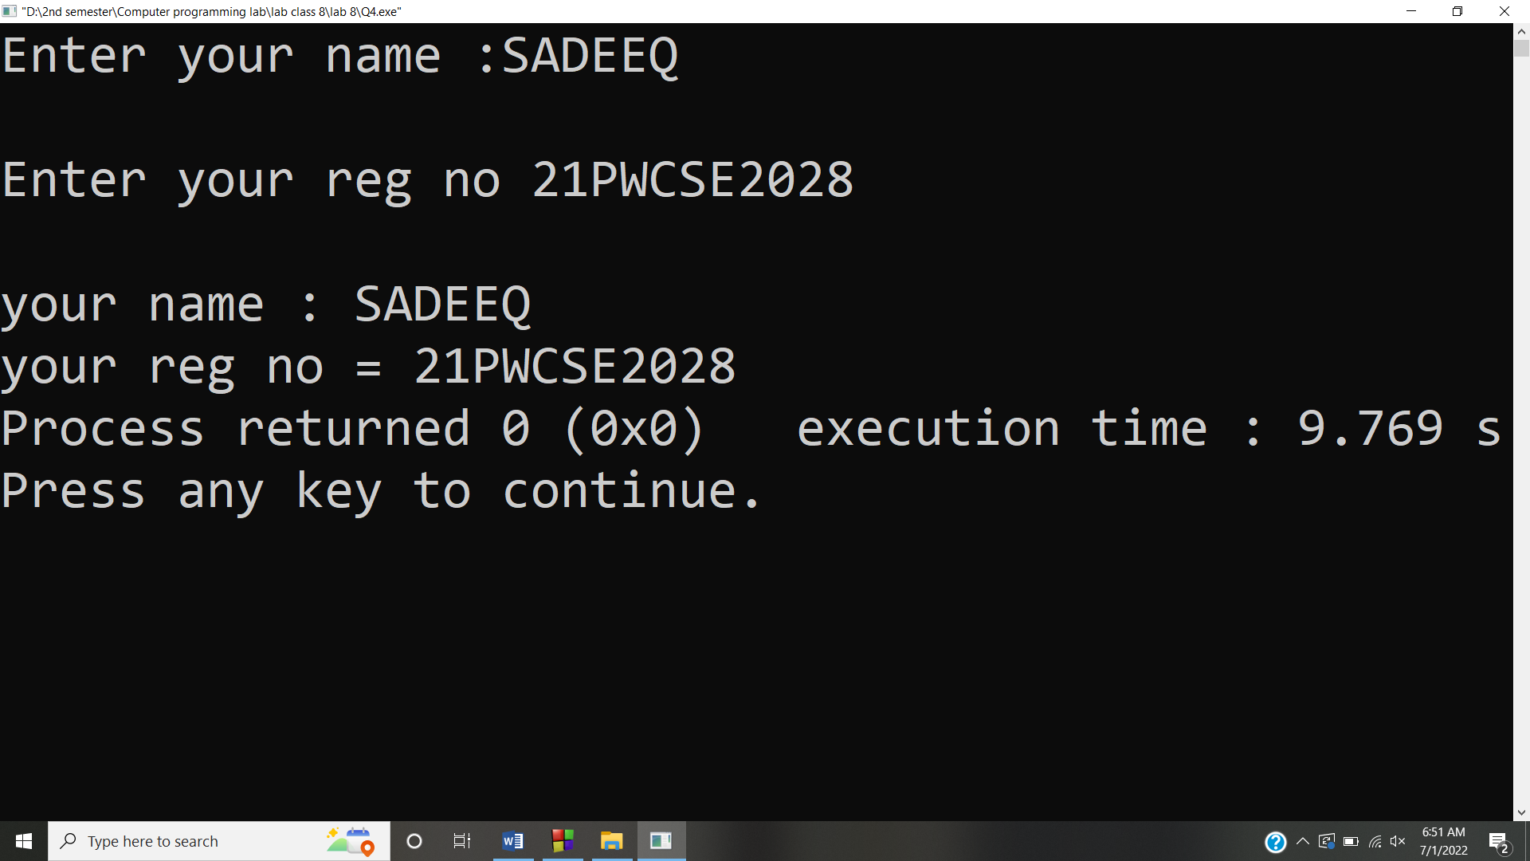

**Answer #5**

**CODE:** 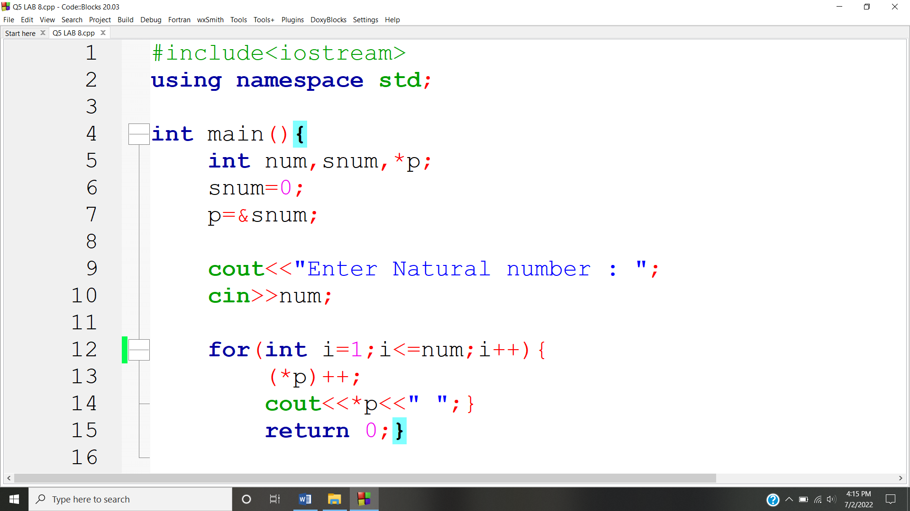

**OUTPUT:** 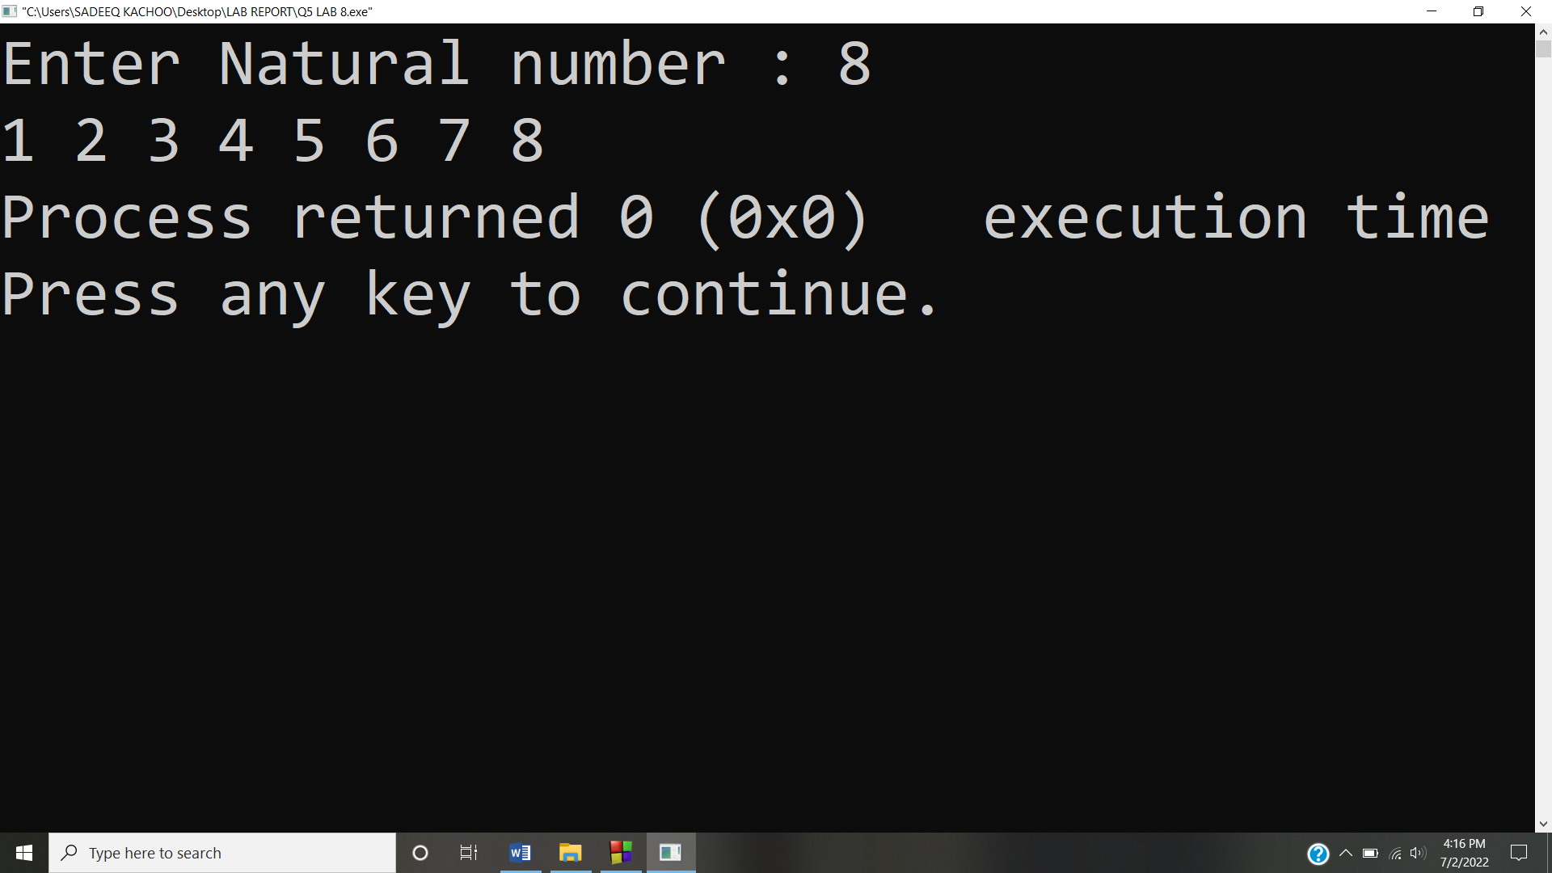

**Answer #6**

**CODE:** 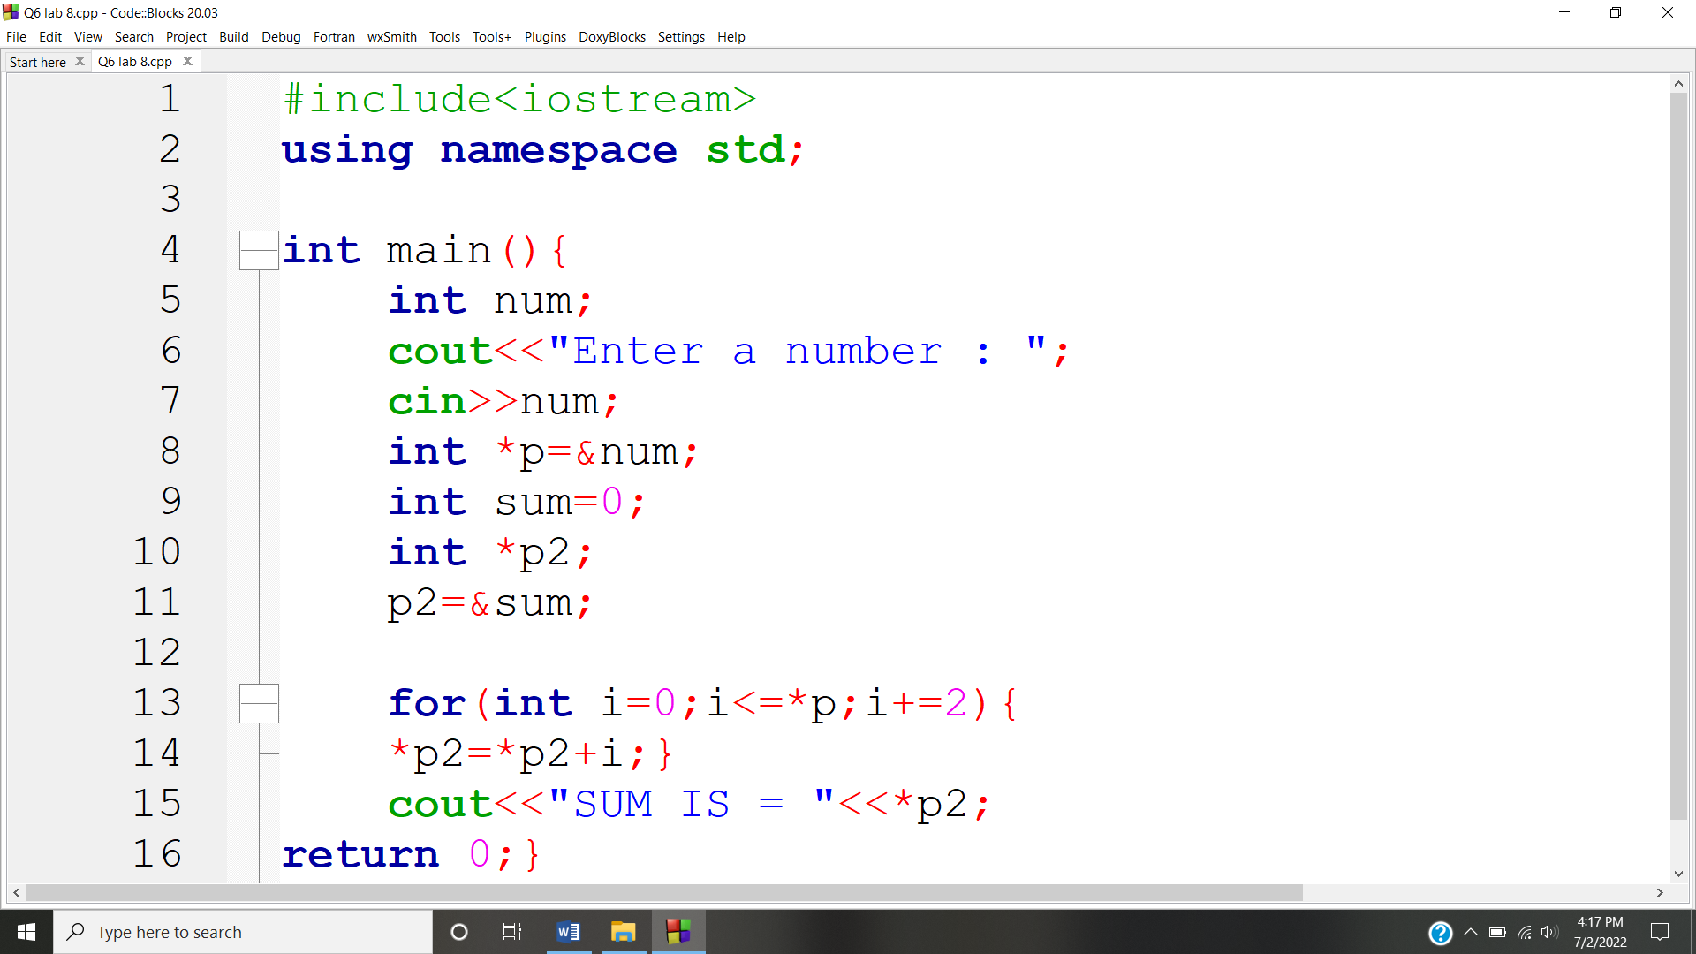

**OUTPUT:** 